**Exercises in JavaScript**

**Date:11.02.2023**

**1.Калкулатор**

**HTML**

**Input the Digits And Operators**

<!DOCTYPE html>

<html lang="en">

  <head>

    <meta charset="UTF-8" />

    <meta http-equiv="X-UA-Compatible" content="IE=edge" />

    <meta name="viewport" content="width=device-width, initial-scale=1.0" />

    <title>Document</title>

    <link rel="stylesheet" href="./main.css">

  </head>

  <body>

    <h1 style="text-align:center">Calculator App</h1>

    <div class="container">

    <br>

    <table>

        <tr>

           <td colspan="3"><input type='text' id='result' class ='screen' style="text-align: right;"></td>

            <td>

                <input type='button' value = 'C' onclick="clearScreen()" class="clear"/>

            </td>

        </tr>

    </table>

    <div class="keys">

    <input type="button" value="7" class="button" onClick="display('7')"></input>

    <input type="button" value="8" class="button " onClick="display('8')"></input>

    <input type="button" value="9" class="button" onClick="display('9')"></input>

    <input type="button" value="/" class="operator" onClick="display('/')"></input>

    <input type="button" value="4" class="button" onClick="display('4')"></input>

    <input type="button" value="5" class="button" onClick="display('5')"></input>

    <input type="button" value="6" class="button" onClick="display('6')"></input>

    <input type="button" value="*" class="operator" onClick="display('*')"></input>

    <input type="button" value="1" class="button" onClick="display('1')"></input>

    <input type="button" value="2" class="button" onClick="display('2')"></input>

    <input type="button" value="3" class="button" onClick="display('3')"></input>

    <input type="button" value="-" class="operator" onClick="display('-')"></input>

    <input type="button" value="0" class="button" onClick="display('0')"></input>

    <input type="button" value="." class="button" onClick="display('.')"></input>

    <input type="button" value= "=" class="button equal-sign" onClick="solve()"></input>

    <input type="button" value="+" class="operator" onClick="display('+')"></input>

</div>

</div>

    <script src="./main.js"></script>

  </body>

</html>

CSS

.container {

    border: 1px solid #cccccc;

    box-shadow: 10px 10px 30px 0px rgba(0,0,0,0.75);

    border-radius: 20px;

    position: absolute;

    top: 55%;

    left: 50%;

    transform: translate(-50%, -50%);

    width: 450px;

    height: 400px;

}

.keys {

    display: grid;

    grid-template-columns: repeat(4, 1fr);

    grid-gap: 10px;

    padding: 10px;

    margin:auto;

}

.button {

    height: 60px;

    padding: 5px;

    background-color: #fff;

    border-radius: 3px;

    border: 1px solid #c4c4c4;

    background-color: transparent;

    font-size: 2rem;

    color: #333;

    background-image: linear-gradient(to bottom, transparent, transparent 50%, rgba(0,0,0,.04));

    box-shadow: inset 0 0 0 1px rgba(255,255,255,.05), inset 0 1px 0 0 rgba(255,255,255,.45), inset 0 -1px 0 0 rgba(255,255,255,.15), 0 1px 0 0 rgba(255,255,255,.15);

    text-shadow: 0 1px rgba(255,255,255,.4);

}

.button:hover {

    background-color: #eaeaea;

}

.operator {

    color: #fff;

    background-color: #eebb24;

}

.clear {

    background-color: #f0595f;

    border-color: #b0353a;

    color: #fff;

    width: 80px;

    height: 30px;

}

.clear:hover {

    background-color: #f17377;

}

.equal-sign {

    background-color: #25a8e0;

    border-color: #25a8e0;

    color: #fff;

}

.equal-sign:hover {

    background-color: #4e9ed4;

}

.screen{

    background-color:rgb(171, 219, 231);

    justify-content: left;

    color: black;

    font-size: medium;

    width: 50%;

    height: 30%;

    cursor: default;

    padding: 10px;

    padding-left: 40%;

    margin: auto;

    margin-bottom: 10px;

}

Javascript

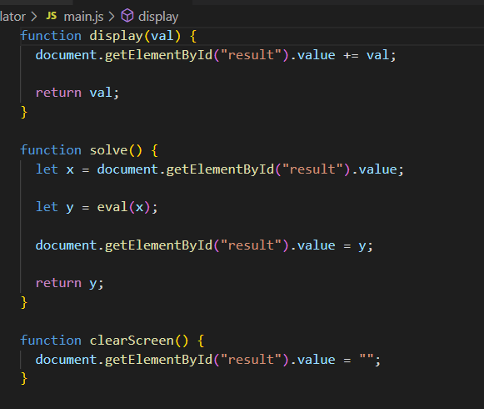

2.Clock

HTML

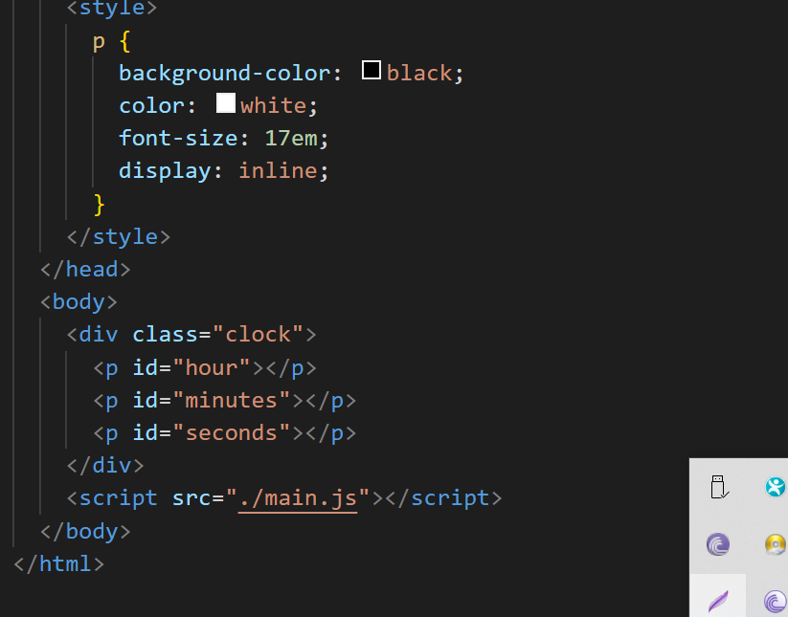

**Javascript**

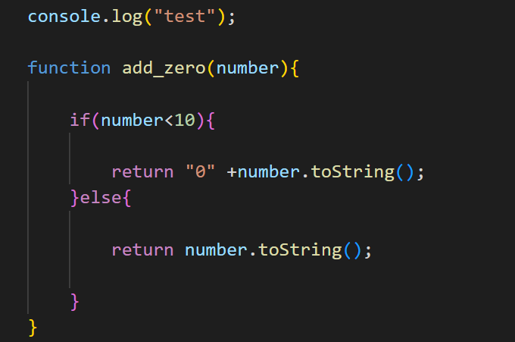

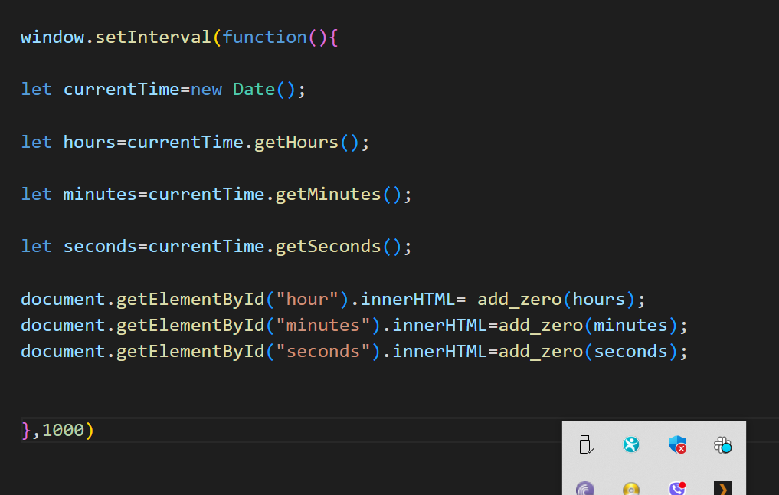

**4. Alarm with Clock**

**HTML**

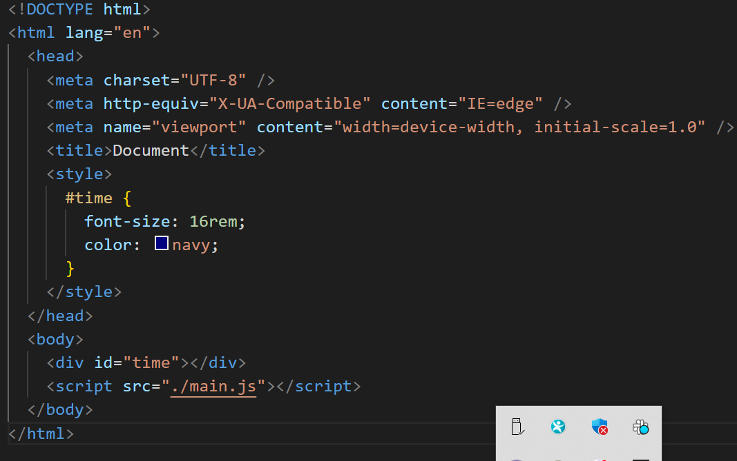

**Javascript**

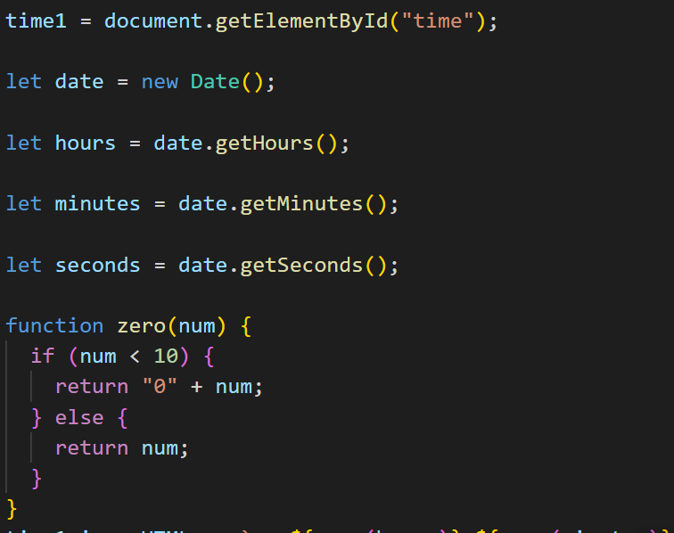

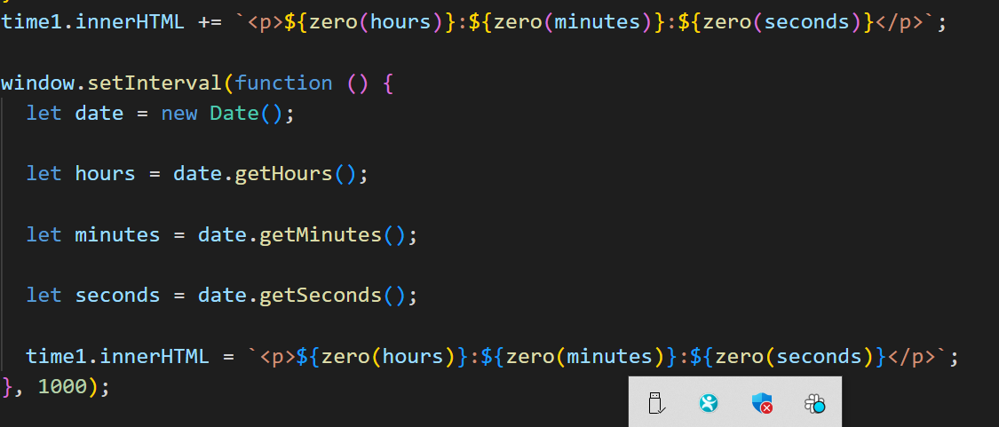

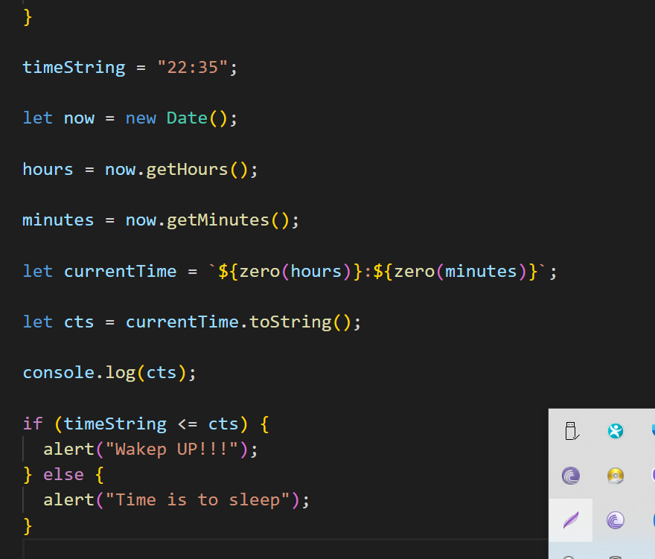

**5.Background color Picker**

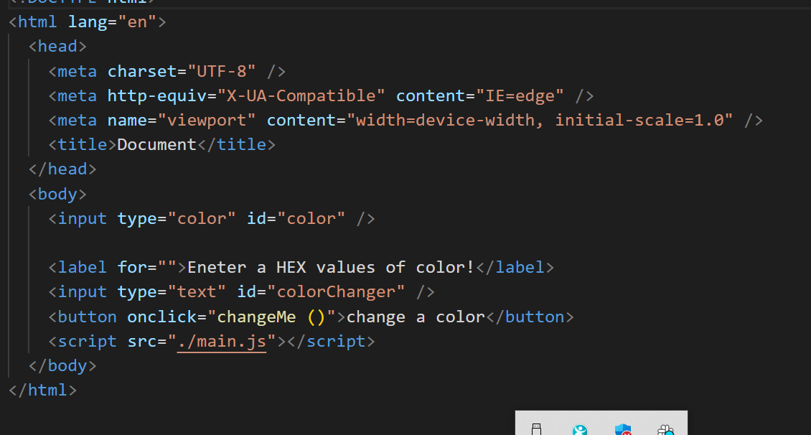

**Javascript**

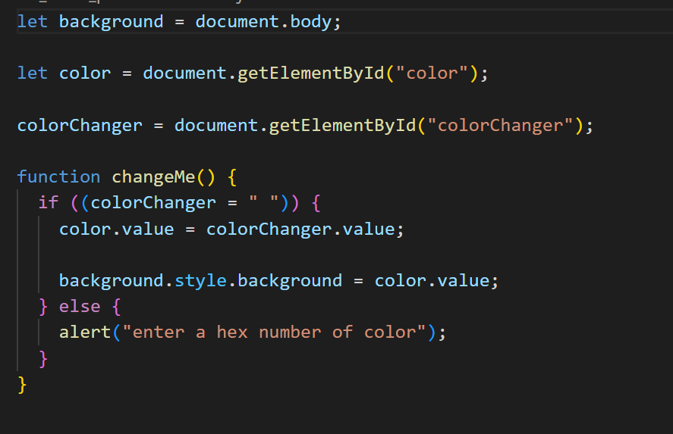

**5. Design a Drum-kit web app using JavaScript**

**First step**

**Designing the HTML Layout:**

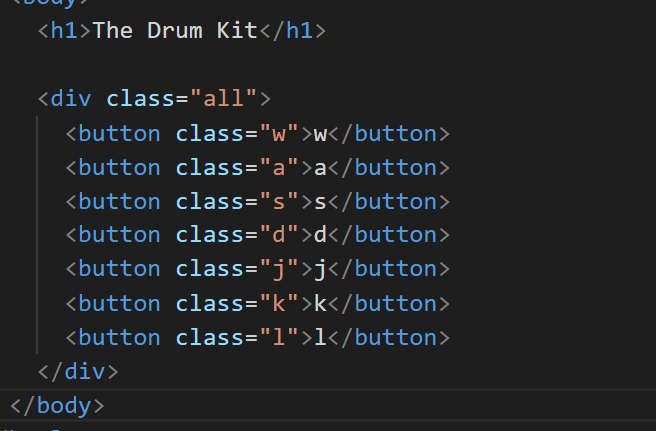

**Output:**

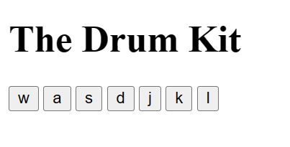

**Second step**

**Adding CSS Styling:**

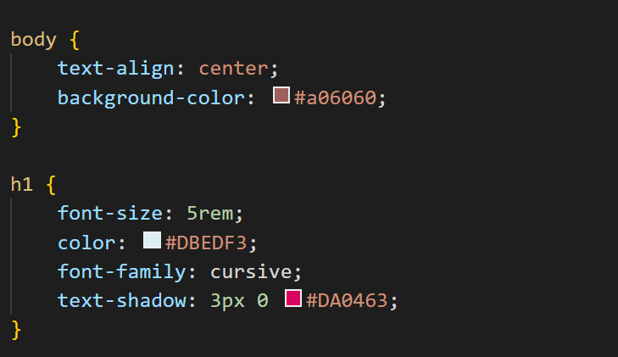

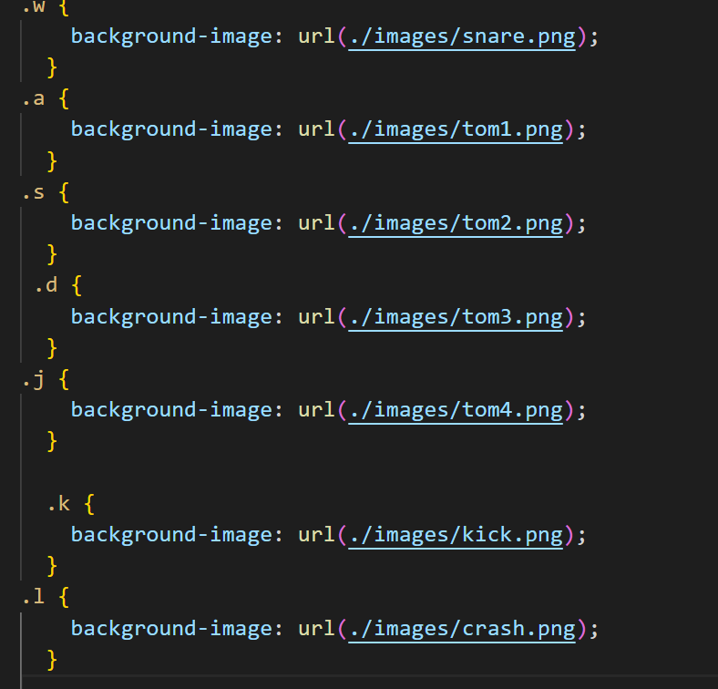

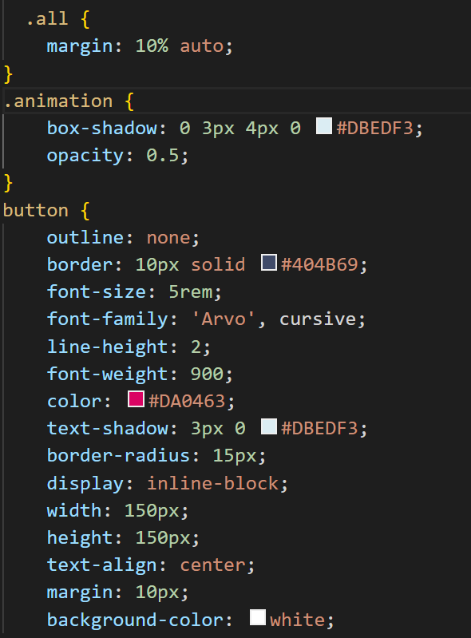

**Output**

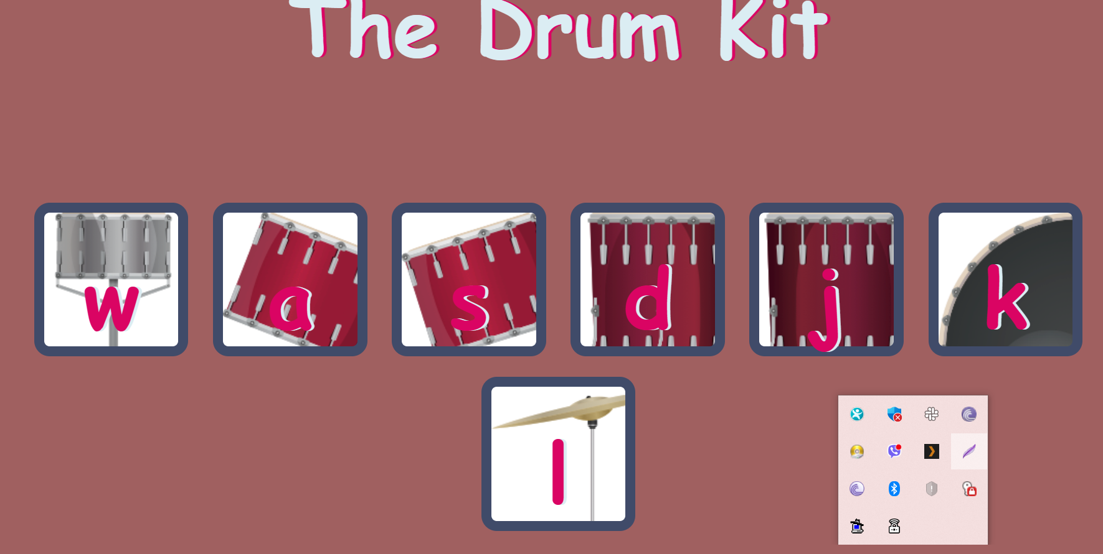

**Javascript:**

**Add event listeners to all the buttons as follows:**

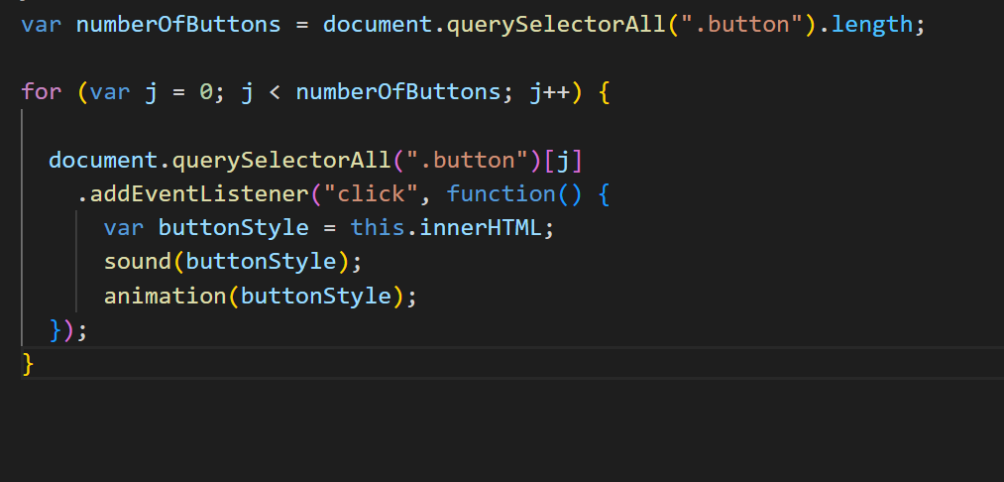

**Add keypress function which will describe what will happen when a particular key is produced. Here we will produce the sound effect and animation effect**

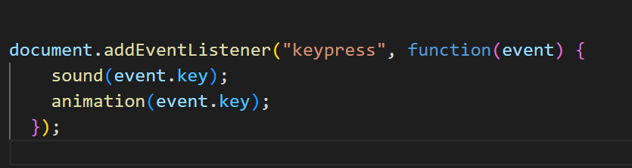

**code sound() function. It will tell which sound should be played when we press or/and click a specific key. Here we have already stored some basic sound effects of drums, cymbals and other percussion instruments, and we will play those sounds (using new Audio) when their respective key is clicked or pressed. All the sounds are in “music” directory. Code for the same should be:**

function sound(key) {

  switch (key) {

    case "w":

      var sound1 = new Audio("sounds/boom.wav");

      sound1.play();

      break;

    case "a":

      var sound2 = new Audio("sounds/clap.wav");

      sound2.play();

      break;

    case "s":

      var sound3 = new Audio("sounds/hihat.wav");

      sound3.play();

      break;

    case "d":

      var sound4 = new Audio("sounds/kick.wav");

      sound4.play();

      break;

    case "j":

      var sound5 = new Audio("sounds/snare.wav");

      sound5.play();

      break;

    case "k":

      var sound6 = new Audio("sounds/openhat.wav");

      sound6.play();

      break;

    case "l":

      var sound7 = new Audio("sounds/ride.wav");

      sound7.play();

      break;

    default:

      console.log(key);

  }

}

**Now we will code animation() function. This will animate the button differently when it is being clicked. To do this, we will add pressed (which we have already defined in CSS file) class to the respective button when it is being clicked. Code for the same would be:**

